FINAL PROJECT
Programming for AI
GROUP MEMBERS:
Sarim Ali Shah (FA23-BAI-047)
Muhammad Eesa Orakzai (FA23-BAI-031)
Cryptocurrency Price Analysis and Prediction

HOW TO USE:
- Download a csv file of any crypto coin from https://www.coingecko.com
- Upload that csv file in streamlit app.
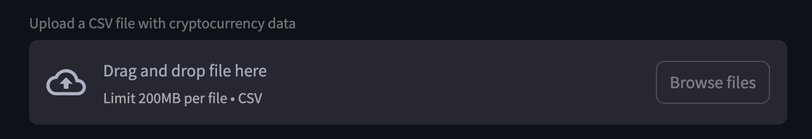
- Let the model do its job and it will predict 6 months of future forcast and provide some useful insights.

EXAMPLE:
Here I have uploaded a csv file of bitcoin.
